GLOBALOKS

TIMESWITCH PROGRAMMING INSTRUCTIONS

There are three buttons that programme the Timeswitch 'PROG', 'SET', 'ADV', and one button 'OVR' which is an override for the current programme that is running i.e. if the clock is in an 'off' time zone, then pressing 'OVR' will turn the clock 'on' and vice versa.
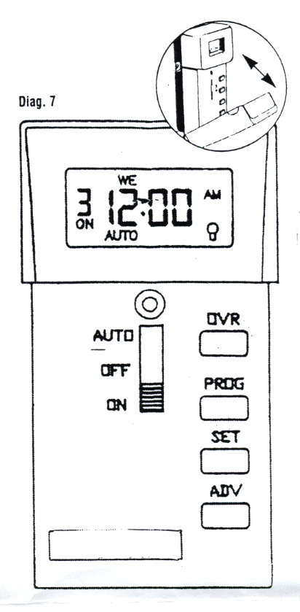

The Timeswitch controls the combination lock. 'ON' times means that the lock can be opened. 'OFF' times means that the lock is prevented from opening and the RED LED on the front of the keypad will flash ever 5 seconds.

Example - ON at 8.30 am - OFF at 5.00 pm
The lock will be operational during the working day and at 5.30 pm the lock will be inoperable until 8.30 am the following day.

IMPORTANT

The Timeswitch does not have its own battery, but is powered by the combination locks batteries housed in the locks external keypad. The time clock will hold the programmed times for a maximum of 24 hours without batteries. It is therefore very important to inform the end user that when changing the batteries in the keypad, this
operation must be carried out within this time period.

The small symbol in the bottom right hand corner of the screen is displayed when the Timeswitch is in an 'ON' time frame.

CONNECTING TIMESWITCH TO THE LOCK

The Timeswitch will not operate until the three cables (2 x red & 1 x black) are connected to the lock body. The single red cable has a plug marked with '3' and on the double set of wires the plug is marked 'B'. On the back of the lock at the opposite end to the lock bolt there is a set of 5 double stacked pins which are partly covered by the lock cover. On the lock cover each set of pin positions are identified by the following: V P 3 D B. Plug the relevant cables into the corresponding positions making sure that the RED cables on both plugs are farthest away from the markings on the lock body

SETTING THE CLOCK

Press 'PROG' and the day will flash at the top of the screen. Press 'ADV' until the current day is reached - then press 'SET' to save.

The hour setting will now flash. Press 'ADV' until the current hour is displayed. This is a repeating 12 hour clock and care must be taken to ensure that you chose the correct time of day either AM or PM as shown on the screen - then press 'SET' to save.

The minute setting will now be flashing. Press 'ADV' until the correct minute is shown - then press 'SET' to save.

'EVENT 1' 'ON' will then be flashing on the screen - press 'PROG' until 'EVENT 7' 'OFF' is showing and then press 'PROG' once more to reach the current time on the screen.

Ensure that the cover is replaced over the programming buttons when you have finished.

SETTING ON / OFF TIMES.

There is a maximum of '7-on' and '7-off' events available.

After setting the minutes, the first default 'EVENT 1' which is an 'ON' setting will now be flashing - Press 'SET' to save.

DAY SETTINGS - ON

Now you will have to select which day or days you wish ‘EVENT 1' 'ON' to operate. Press 'ADV' repeatedly to select an individual day or group of days. The initial screen will allow for saving individual days or thereafter, groups of days on a rolling programme. Repeated pressing of 'ADV' will bring you back to the initial screen.

MO - TU - WE - TH - FR - SA or SU. (Individual days)
MO - TU - WE - TH - FR (The same setting for all weekdays)
SA - SU (The same setting for weekends)
MO - TU - WE - TH - FR - SA - SU (The same setting all week)

Press 'SET' to save your choice. Press 'ADV' until the desired hour is displayed, and the correct AM or PM is shown, then press 'SET' to save.

The minutes will now flash, press 'ADV' until the desired minutes are displayed and then press 'SET' to save.

After setting the minutes, the next default 'EVENT 1' which is an 'OFF' setting will now be flashing - Press 'SET' to save.

DAY SETTINGS - OFF

Now you will have to select which day or days you wish ‘EVENT 1' 'OFF' to operate. Press 'ADV' repeatedly to select and individual day or group of days. The initial screen will allow for saving individual days or thereafter groups of days on a rolling programme. Repeated pressing of 'ADV' will bring you back to the initial screen.

MO - TU - WE - TH - FR - SA or SU. (Individual days)
MO - TU - WE - TH - FR (The same setting for all weekdays)
SA - SU (The same setting for weekends)
MO - TU - WE - TH - FR - SA - SU (The same setting all week)

Press 'SET' to save your choice. Press 'ADV' until the desired hour is displayed, and the correct AM or PM is shown, then press 'SET' to save.

The minutes will now flash, press 'ADV' until the desired minutes are displayed and then press 'SET' to save.

'EVENT 2' will now be flashing 'ON' - if you do not wish to programme any additional times press 'PROG' until you reach 'EVENT 7' with the 'OFF' flashing. Press 'PROG' once more to reach the current time on the screen.

To view saved events press the 'PROG' button to scroll through menu.

To clear an unwanted ON/OFF event, go to the relevant 'EVENT' by pressing 'PROG' and then press 'ADV', and this will permanently clear the event from the memory.

EXAMPLE OF OPENING & CLOSING TIMES

If you require the combination lock to open and close at the same time every day and different times for the weekend, choose the same setting for all weekdays for
'EVENT 1' ‘ON/OFF' and use 'EVENT 2' 'ON/OFF' for SA & SU if opening times are different to the weekdays, or you can programme 'EVENT 2' 'ON/OFF' for SA, and 'EVENT 3' 'ON/OFF' for SU.

When you have finished programming the Timeswitch and the current time is within the 'ON' set time, you will find that the open symbol will not be shown in the bottom right hand corner of the screen, and the lock will not operate. Press the 'OVR' button once and the symbol will appear and the lock will operate. Leave the Timeswitch in this mode, and when the next 'OFF' period is due, the Timeswitch will revert to the newly programmed times.

Ensure that the cover is replaced over the programming buttons when you have finished.

TO RESET CURRENT TIME FOR DAYLIGHT SAVINGS

Open front cover and press 'PROG' button once.

Ensure that the correct day is shown which will be flashing at the top of the screen, if it is press 'SET'. If the incorrect day is shown press 'ADV' until the current day is reached - then press 'SET' to save.

The hour setting will now flash. Press 'ADV' until the current hour is displayed. This is a repeating 12 hour clock and care must be taken to ensure that you chose the correct time of day either AM or PM as shown on the screen - then press 'SET' to save.

The minute setting will now be flashing. Press 'ADV' until the correct minute is shown - then press 'SET' to save.

'EVENT 1' 'ON' will then be flashing on the screen - press 'PROG' until 'EVENT 7' 'OFF' is showing and then press 'PROG' once more to reach the current time on the screen.

Ensure that the cover is replaced over the programming buttons when you have finished.

IF YOU ARE IN ANY DOUBT ABOUT THE PROGRAMMING OF THIS TIME CLOCK DO NOT, UNDER ANY CIRCUMSTANCES, CLOSE AND LOCK THE SAFE DOOR AS YOU MAY NOT BE ABLE TO OPEN THE SAFE AGAIN!

If the above situation arises, you must obtain professional help to ensure that the programming is correct, so that the safe is operational and can be opened at the required times.

